D.Y. PATIL COLLEGE OF ENGINEERING & TECHNOLOGY, KOLHAPUR
(An Autonomous Institute)


DEPARTMENT OF CSE (DATA SCIENCE)

A
Synopsis Report
on
“ASHA SATHI”
Submitted by
Name | Roll No.
Ms. Samruddhi Gangaram Gore | 205
Mr. Shreyash Vinayak Bagade | 206
Ms. Namrata Dilip Belvekar | 207
Mr. Ritesh Prabhakar Patil | 208

Under the guidance of
Ms. A. M. Chavan

Final Year B. Tech. CSE (Data Science)
Academic Year 2026-27

INDEX

Sr. No. | Topic | Page Number
1. | Abstract
2. | Introduction
3. | Literature Survey
4. | Motivation
5. | Problem Definition  - Problem Statement  - Objectives  - Proposed Architecture  - Experimental Setup
6. | References
7. | Approval statement
8. | Plagiarism Report

ABSTRACT

ASHA Sathi is an offline-first rural healthcare management system designed to improve healthcare data collection, monitoring, communication, and service delivery in rural communities. It addresses challenges faced by ASHA (Accredited Social Health Activist) workers, including limited internet connectivity, manual record keeping, delayed reporting, and difficulty maintaining accurate patient information. The system consists of three main users: PHC Admin, ASHA Worker, and Patient. PHC Admin manages ASHA workers, patient records, vaccination and health check-up information, reports, notifications, and healthcare activities, while ASHA workers use a mobile application to register patients, collect health information, conduct surveys, and update records during field visits.
The system follows an offline-first approach, allowing ASHA workers to continue their activities without an active internet connection. Patient and health information is stored locally and synchronized with the central system when connectivity becomes available. Patients can access essential healthcare information, vaccination details, reminders, referrals, and follow-up support through suitable communication channels. Overall, ASHA Sathi aims to reduce paperwork, improve the accuracy and accessibility of healthcare records, simplify PHC monitoring, and strengthen coordination between ASHA workers, PHCs, and patients, providing a reliable platform for efficient rural healthcare management.

INTRODUCTION

Healthcare is an essential part of community development, but rural and remote communities often face difficulties such as limited healthcare facilities, shortage of medical professionals, poor internet connectivity, and lack of digital infrastructure. These challenges can make the collection, updating, storage, and sharing of patient health information slow and difficult. ASHA (Accredited Social Health Activist) workers play an important role in addressing these gaps by connecting rural communities with healthcare facilities and supporting various healthcare activities.
ASHA workers conduct household visits, register patients, collect health information, monitor vaccinations, support maternal and child healthcare, provide health awareness, and assist patients with referrals to Primary Health Centers (PHCs). However, many of these activities still depend on manual records and communication methods, which can increase workload and make healthcare data management difficult. Digital Electronic Health Records (EHRs) can improve record management, but conventional systems often depend on continuous internet connectivity, which is not reliable in many rural areas.
ASHA Sathi is proposed as an offline-first rural healthcare management system that connects PHC Administrators, ASHA Workers, and Patients through a centralized digital platform. ASHA workers can register patients, collect and update health information, manage household visits, track vaccinations, handle referrals, and maintain digital patient records even when there is no active internet connection. The system stores information locally and automatically synchronizes it with the central database whenever internet connectivity becomes available, allowing healthcare activities to continue without interruption.
The system also includes AI-based risk prediction and decision support to identify potentially high-risk patients and help ASHA workers prioritize cases requiring timely medical attention. A centralized PHC dashboard provides patient status, healthcare activities, reports, and monitoring information for administrators. Overall, ASHA Sathi aims to reduce paperwork, improve the accuracy and accessibility of patient records, simplify healthcare monitoring, support timely follow-ups, and strengthen coordination between patients, ASHA workers, and PHC staff.

LITERATURE SURVEY

The literature survey focuses on mHealth applications, Electronic Health Record (EHR) systems, ASHA worker healthcare services, and offline-first rural healthcare solutions. Existing studies show that digital healthcare systems can improve patient monitoring, record management, and healthcare delivery. However, rural healthcare workers still face challenges such as poor internet connectivity, manual documentation, limited digital infrastructure, and lack of intelligent decision support.
ANMOL [1] is a government-supported digital healthcare application designed to assist frontline health workers in managing maternal and child healthcare information. It supports activities such as beneficiary registration, health monitoring, and maintaining service-related records. However, some of its functions depend on network availability, which can create difficulties for healthcare workers operating in areas with poor connectivity.
RCH Portal [2] is a digital platform developed for monitoring reproductive, maternal, newborn, and child healthcare services. It helps maintain information related to pregnant women, mothers, children, antenatal care, postnatal care, and immunization. However, its primary focus is reproductive and child healthcare, and it provides limited AI-based decision support for identifying high-risk patients.
eSanjeevani [3] is a government telemedicine platform that enables patients to access healthcare professionals through digital consultation services. It mainly focuses on remote consultation and communication between patients and healthcare providers. However, it does not primarily address offline EHR management, AI-based risk prediction, or intelligent planning of ASHA workers' field visits.
Poshan Tracker [4] is a digital platform used for monitoring nutrition and child development services. It helps track beneficiaries, nutrition-related activities, and growth information. However, its functionality is mainly centered on nutrition monitoring and does not provide a complete healthcare record system covering broader patient health information, AI-based prediction, and PHC-level healthcare management.
Ayushman Bharat Digital Mission (ABDM) [5] provides a national digital health infrastructure that supports the creation, management, and exchange of digital health information. It promotes interoperability and enables patients and healthcare providers to participate in a connected digital health ecosystem. However, ABDM is a broader digital health framework rather than a dedicated offline-first application designed specifically for ASHA workers and their field-level activities.
ASHA Sathi [6] is proposed to address these limitations by providing an integrated rural healthcare management platform connecting Patients, ASHA Workers, and PHC Administrators. It combines offline EHR management, automatic synchronization, AI-based risk prediction, smart visit planning, vaccination tracking, and PHC-level analytics to support efficient healthcare delivery in rural communities.

MOTIVATION

The motivation for developing ASHA Sathi comes from the challenges faced by ASHA workers while providing healthcare services in rural areas. ASHA workers regularly visit patients, collect health information, track vaccinations and follow-ups, and coordinate with PHC staff. However, these activities are often affected by manual record keeping, poor internet connectivity, data synchronization problems, and limited access to intelligent healthcare support.
The project is motivated by the need for a simple, offline-first and AI-enabled healthcare management system that allows ASHA workers to continue their work without continuous internet connectivity. The system stores information locally and synchronizes it automatically when connectivity is available. It also supports AI-based risk prediction, patient tracking, smart visit planning, and PHC-level monitoring.
The main purpose of ASHA Sathi is to reduce the workload of ASHA workers, improve patient record management, enable early identification of high-risk patients, and improve coordination between patients, ASHA workers, and PHC administrators. This can contribute to more efficient and accessible healthcare services in rural communities.

PROBLEM DEFINITION

- Problem Statement:
ASHA Sathi is developed to solve existing challenges faced by ASHA workers, such as poor internet connectivity, manual record keeping, delayed updates, and difficult patient monitoring. The system uses an offline-first mobile application, centralized database, synchronization to provide reliable and efficient rural healthcare management.
- Objectives:
The objectives of the proposed project are:

- To develop a centralized healthcare system connecting Patients, ASHA Workers, and PHC Administrators for better healthcare management.

- To provide an offline-first mobile application that allows ASHA workers to register patients, manage digital health records, track vaccinations, check-ups, referrals, and follow-ups without continuous internet.

- To enable automatic synchronization and communication by syncing data when internet is available and providing notifications and reminders to patients and healthcare workers.

- To improve rural healthcare efficiency through centralized PHC monitoring, reporting, and better coordination between patients, ASHA workers, and PHC staff.

- Proposed Architecture:
Architecture Modules
1. ASHA Worker Module
- Patient Registration and Management: Register and manage patient details.
- Health Data Collection: Record patient health information.
- Offline Data Entry: Enter and save data without internet.
- Vaccination and Follow-up Tracking: Monitor vaccinations and scheduled visits.
- Automatic Data Synchronization: Sync offline data when internet is available.

2. Patient Module
- Patient Registration and Authentication: Create and securely access patient accounts.
- Health Information Management: View and manage personal health information.
- Vaccination Status: Check vaccination records and upcoming doses.
- Appointment and Follow-up Tracking: Track healthcare visits and follow-ups.
- Notifications and Reminders: Receive important healthcare alerts.
- Consent and Privacy Management: Manage permission for sharing health information.
3. AI Intelligence Module
- Health Risk Prediction: Analyze health data to estimate potential risks.
- High-Risk Patient Identification: Identify patients requiring special attention.
- Risk Score Generation: Generate simple risk levels such as low, medium, or high.
- Predictive Healthcare Analytics: Analyze health data to support future healthcare decisions.
4. PHC Admin Module
- Dashboard Monitoring: View overall healthcare activities.
- ASHA Worker Management: Manage and monitor ASHA workers.
- Patient Monitoring: View and track registered patients.
- Risk Case Monitoring: Monitor high-risk patients and cases.
- Reports and Analytics: Generate healthcare reports and insights.
- Vaccination and Program Monitoring: Monitor vaccination and healthcare programs.
5. Communication & Notification Module
- Vaccination Reminders: Notify users about upcoming vaccinations.
- Check-up Reminders: Remind patients about scheduled check-ups.
- Follow-up Notifications: Send reminders for required follow-ups.
- Health Alerts: Provide important health-related alerts.
- Referral Notifications: Inform users about referrals and healthcare visits.
- ASHA–PHC Communication: Support communication between ASHA workers and PHC staff.
6. Offline & Synchronization Module
- Offline Patient Data Storage: Store data when internet is unavailable.
- Local SQLite Database: Maintain patient data locally on the device.
- Internet Connectivity Detection: Detect when network connectivity is restored.
- Automatic Cloud Synchronization: Upload stored data to the central system automatically.

7. Database Layer
- User Information: Stores user accounts and roles.
- Patient Records: Stores patient registration details.
- Health Records: Stores medical and health information.
- Risk Predictions: Stores AI-generated risk results.
- Vaccination Records: Stores vaccination history and schedules.
- Notifications: Stores alerts and reminders.
- Sync Queue Data: Stores offline changes waiting for synchronization.
8. Infrastructure Layer
- Cloud Server: Provides remote access to healthcare services.
- Application Server: Handles application logic and requests.
- Database Server: Manages centralized healthcare data.
- Backup and Recovery: Protects and restores important data.
- API Services: Enables communication between application components.
- Cloud Data Storage: Stores synchronized healthcare information securely.

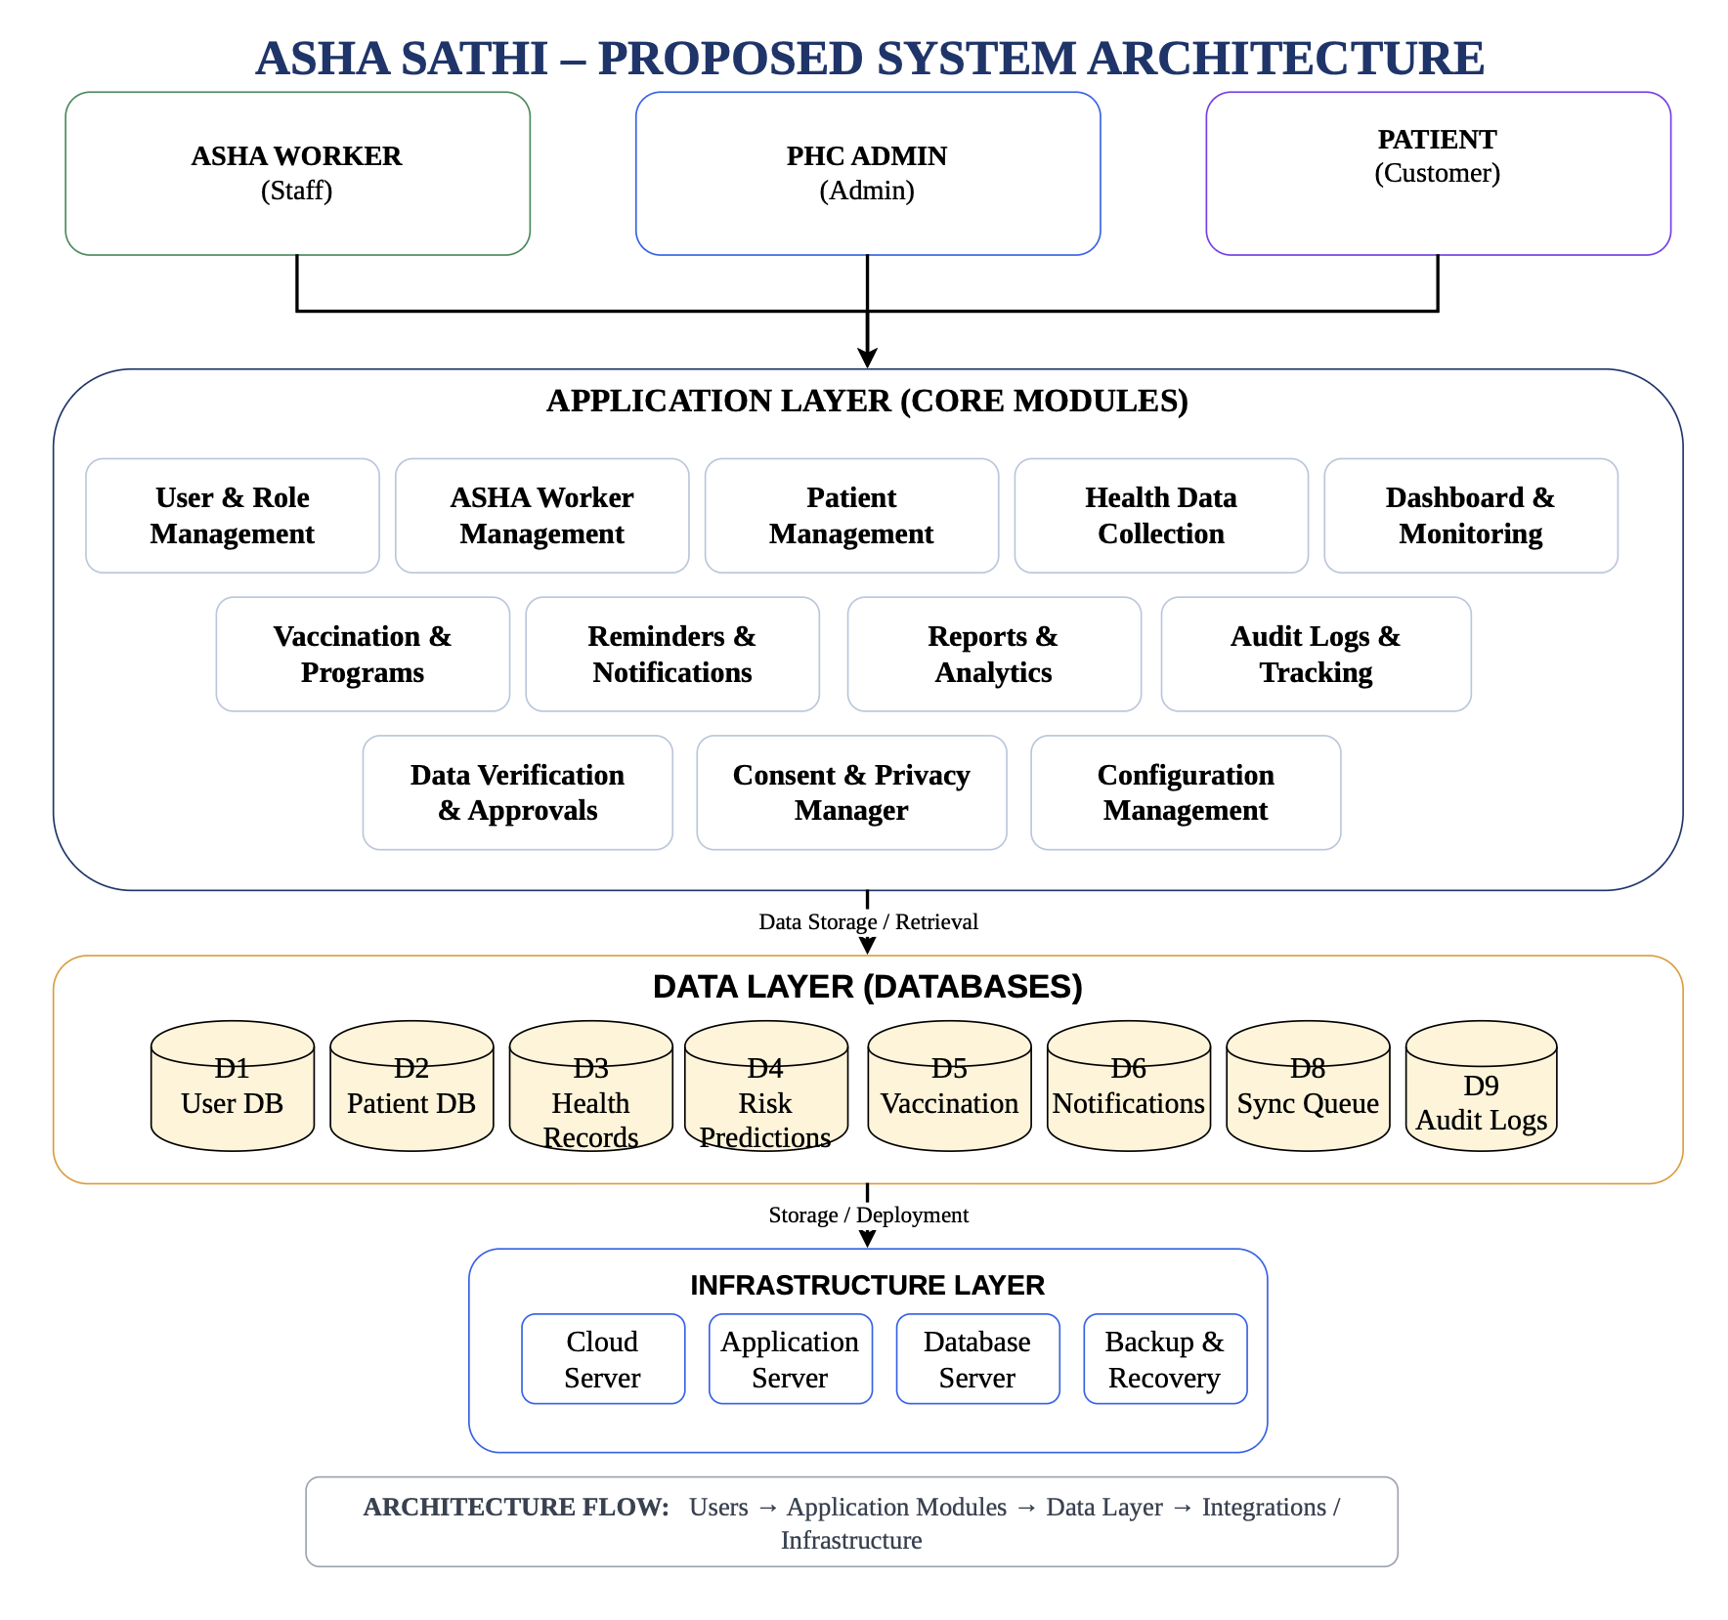

- Experimental Setup:
- Software requirements
Software | Requirement
Operating System | Windows 10/11, Linux, or macOS
Mobile Development | Flutter & Dart
Web Development | React.js
Backend | Python + FastAPI
Database | PostgreSQL
Offline Database | SQLite
IDE | Visual Studio Code / Android Studio
API Testing | Postman
Version Control | Git & GitHub
Browser | Google Chrome / Microsoft Edge
Diagram Tool | Draw.io

- Hardware requirements
Hardware | Minimum Requirement
Processor | Intel Core i3 / AMD Ryzen 3 or higher
RAM | 8 GB minimum
Storage | 256 GB SSD or higher
Display | 1366 × 768 or higher
Smartphone | Android 8.0 or above
Internet | Wi-Fi / Mobile Internet for synchronization
Server | Cloud or local application server
Backup | External/Cloud storage

- Libraries

Frontend
- Flutter & Dart – ASHA Worker mobile application
- React.js – PHC Admin dashboard
- Axios – API communication
- Recharts / Chart.js – dashboard visualization

Backend
- FastAPI (POSTMAN) – REST API development
- SQLAlchemy – database connectivity
- Pydantic – data validation
- JWT – authentication and authorization

AI/ML
- Python – AI/ML development
- Pandas – data processing
- NumPy – numerical operations
- Scikit-learn – health-risk prediction
- Matplotlib – result visualisation
- Joblib – saving trained ML models

Database & Services
- PostgreSQL – centralized database
- SQLite – Offline/local database
- Firebase Cloud Messaging (FCM) – push notifications
- Git/GitHub – source-code management

REFERENCES

[1] | S. Agarwal, G. A. Perry, A. Long, and J. Labrique, “Evidence on Feasibility and Effective Use of mHealth Strategies by Community Health Workers in Low- and Middle-Income Countries: Systematic Review,” Journal of Medical Internet Research, Vol. 17, No. 8, e208, 2015.
[2] | R. Braun, C. Catalani, J. Wimbush, and D. Israelski, “Community Health Workers and Mobile Technology: A Systematic Review of the Literature,” PLoS ONE, Vol. 8, No. 6, e65772, 2013.
[3] | L. Aranda-Jan, N. Mohutsiwa-Dibe, and S. Loukanova, “Systematic Review on What Works, What Does Not Work and Why of Implementation of Mobile Health (mHealth) Projects in Africa,” BMJ Open, Vol. 4, No. 2, e004794, 2014.
[4] | C. Källander, J. Tibenderana, O. Akpogheneta, D. Strachan, S. Hill, A. ten Asbroek, et al., “Mobile Health (mHealth) Approaches and Lessons for Increased Access to Healthcare in Developing Countries,” Global Health Action, Vol. 6, No. 1, 20945, 2013.
[5] | K. Odendaal, N. Goudge, S. Griffiths, T. Tomlinson, and C. Leon, “Health Workers’ Perceptions and Experiences of Using mHealth Technologies to Deliver Primary Healthcare Services: A Qualitative Evidence Synthesis,” Cochrane Database of Systematic Reviews, No. 3, CD011942, 2020.
[6] | A. Labrique, C. Vasudevan, E. Kochi, R. Fabricant, and G. Mehl, “mHealth Innovations as Health System Strengthening Tools: 12 Common Applications and a Visual Framework,” Global Health: Science and Practice, Vol. 1, No. 2, pp. 160–171, 2013.
[7] | S. F. M. Free, G. Phillips, L. Watson, L. Galli, L. Felix, P. Edwards, V. Patel, and A. Haines, “The Effectiveness of M-health Technologies for Improving Health and Health Services: A Systematic Review,” BMC Public Health, Vol. 13, No. 1, pp. 1–12, 2013.
[8] | M. L. Lewis and C. J. P. Wyatt, “mHealth and Mobile Medical Apps: A Framework to Assess Risk and Promote Safer Use,” Journal of Medical Internet Research, Vol. 16, No. 9, e210, 2014.

APPROVAL STATEMENT

This is to certify that the synopsis report entitled "ASHA SATHI" has been thoroughly reviewed by the expert panel members of CSE (Data Science) Department at D. Y. Patil College of Engineering & Technology, Kolhapur. The content of the synopsis report has been verified for the accuracy, and the proposed work has been approved for the further developments.

Roll No. | Unique ID | Student’s Name | Signature
205 | DSE24120804 | Ms. Samruddhi. G. Gore
206 | DSE24132414 | Mr. Shreyash. V. Bagade
207 | DSE24122385 | Ms. Namrata. D. Belvekar
208 | DSE24130007 | Mr. Ritesh. P. Patil

Date:
Place:

Ms. A. M. Chavan | Mrs. M. M. Wakarekar / Mr. S. M. Ingavale | DR. G. V. Patil
Project Guide | Project Co-ordinators | HOD  (Data Science)

PLAGIARISM REPORT

Attach screenshot of Plagiarism report checked from library.

